**A sigh of the Ventilator**

The Trump-Cuomo Duel over the number of ventilators New York will need over the next few weeks has left many of us both baffled and frightened. How can we win a battle when our generals cannot agree on the number of swords? Public opinion over social media suggests that many of us want to crush the former, and are crushing over the latter. But who is right after all? Is there a simple way for commoners like us to figure out ourselves? After all, most of us have proved to be better planners for our household provisions than the Public Health Planners of the United States.

To think of not getting a ventilator in the hour of need is indeed scary. Are we really doomed? If yes, then when exactly is the doomsday?

In this article, we discuss how one can use basic arithmetic, common sense, and a little extrapolation to approximate the number of hospital beds and ventilators a city may need over the next few weeks.

Caveat: Roller Coaster curves ahead, Not for the weak of heart.

1. *Get the Data*: Johns Hopkins University Center for Systems Science and Engineering (JHU CSSE) operates a [Github Repository](https://github.com/CSSEGISandData/COVID-19) for daily reports on daily, and cumulative, confirmations, deaths and recoveries of COVID-19 patients for different cities across the globe, and of course the United States. We can easily filter the numbers for any city.
2. *Fit the Curve:* Using a simple excel spreadsheet or any data analysis software, we can visualise that the graphs of total confirmed cases and total deaths have been growing exponentially with time and experts believe the trend to continue at least for the next few weeks (data on recoveries at a city level was not available at the time of writing this article). Excel and almost all softwares allow us to fit exponential curves on total confirmations and total deaths and extrapolate the same to predict the total number of active cases (total confirmations - total deaths) of COVID-19 over the next few weeks.

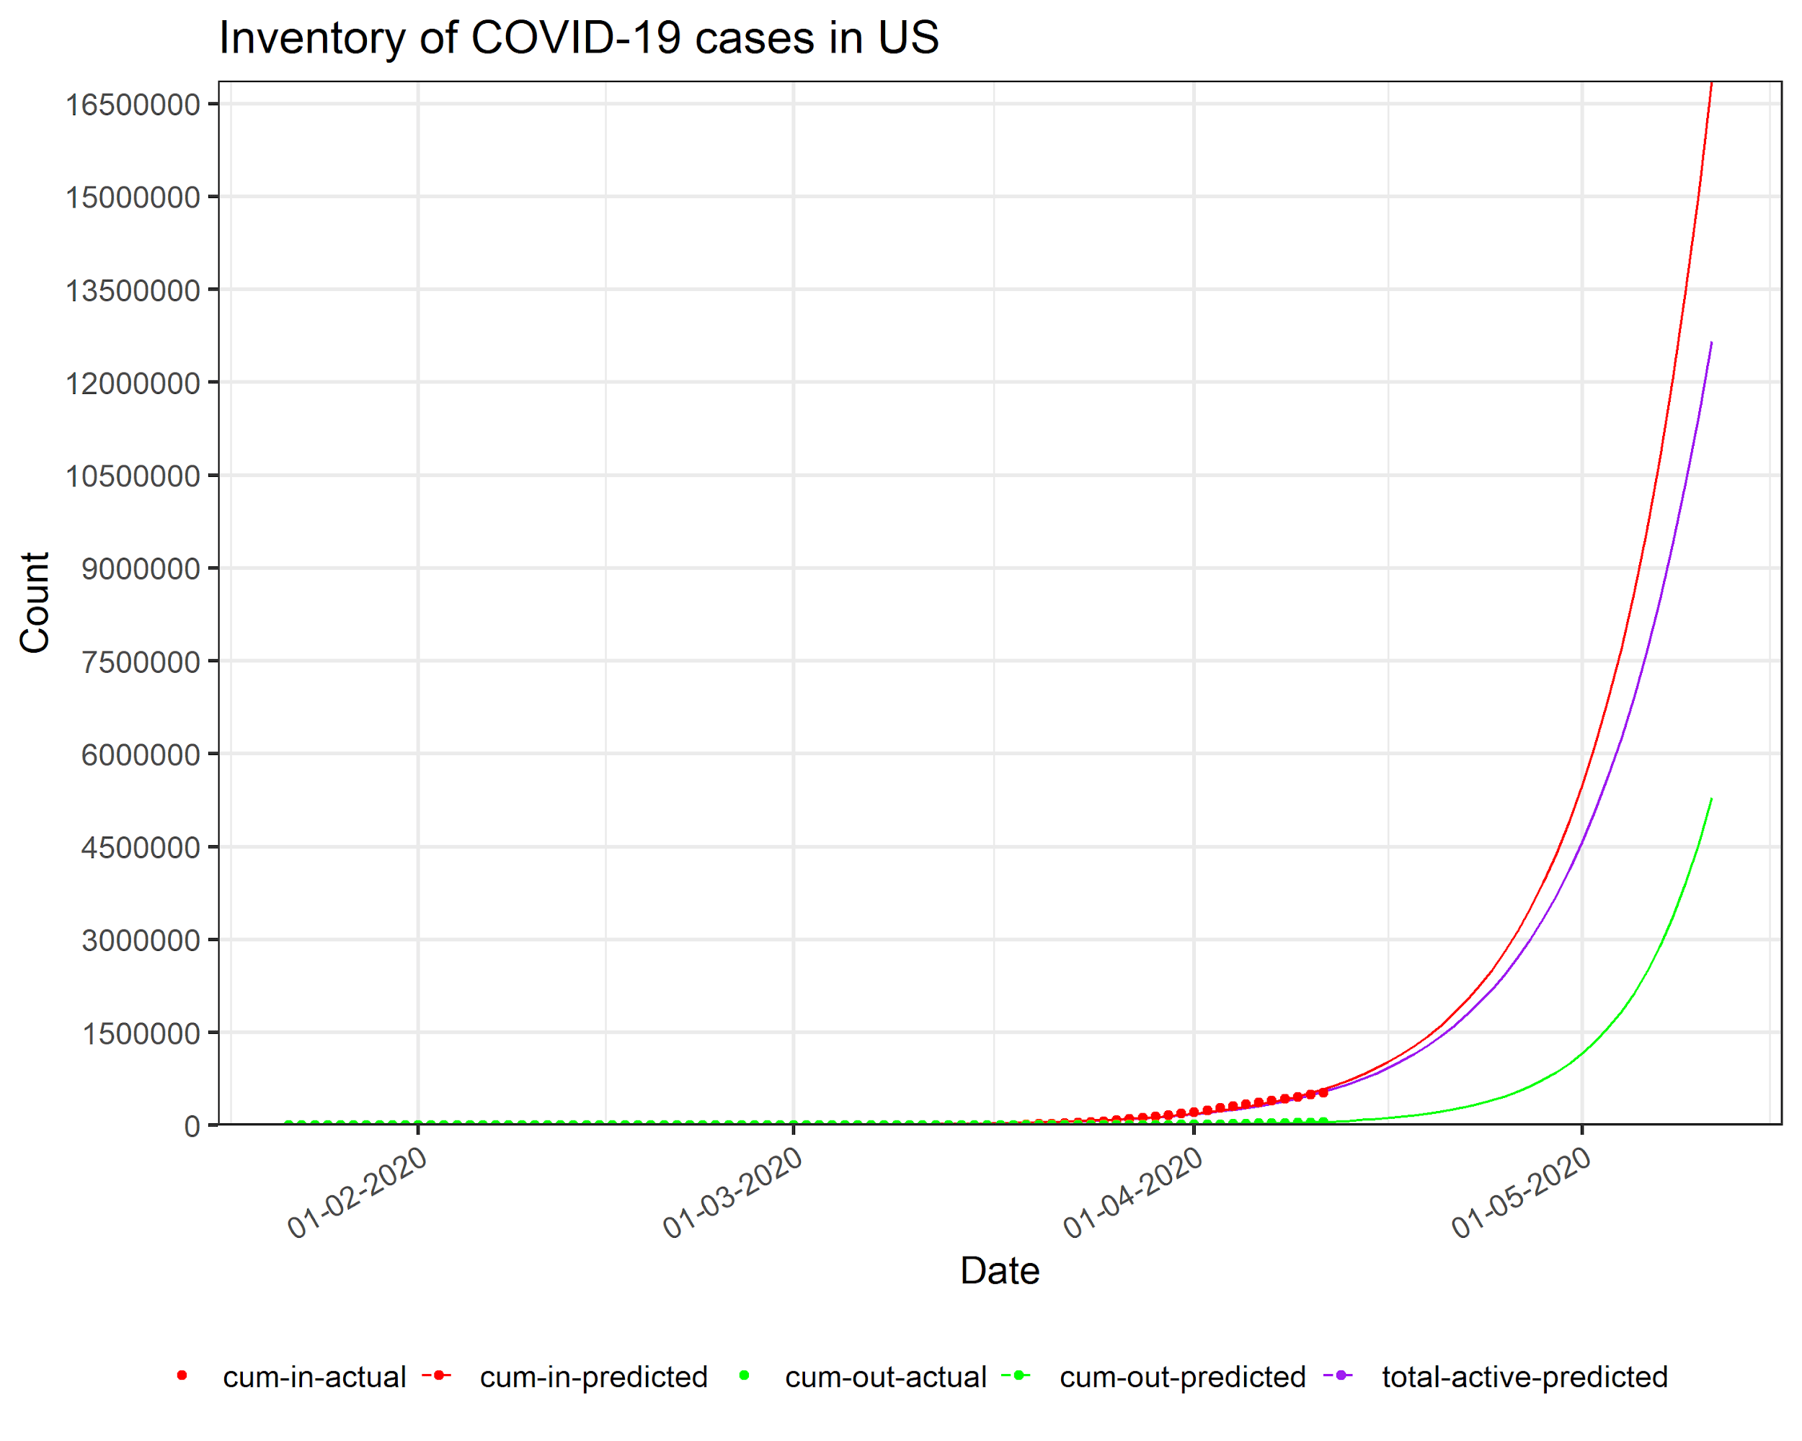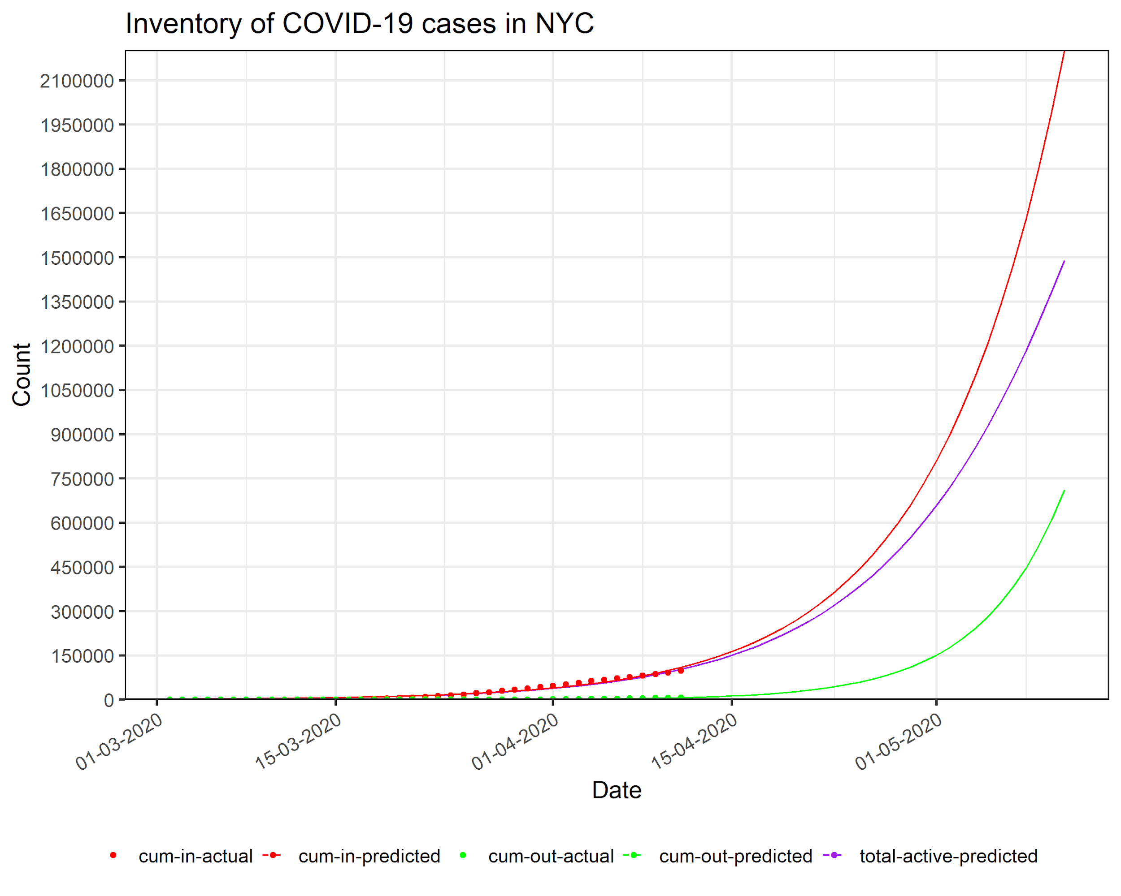

1. *Predict the Inflow and Outflow into Hospitals*: Googling for the hospitalization rate of COVID-19 patients quickly leads to many journals and [news articles](https://www.barrons.com/articles/u-s-coronavirus-hospitalizations-approach-30-here-are-the-latest-covid-19-data-51586175360) that peg the number to be around [26%.](https://www.businessinsider.com/new-york-city-coronavirus-covid19-outbreak-compared-united-states-2020-3#about-42-of-coronavirus-patients-hospitalized-in-new-york-city-so-far-are-65-or-older-thats-similar-to-the-nationwide-portion-forty-five-percent-of-us-hospitalizations-are-in-the-same-age-group-2) We can therefore approximate the daily inflow into hospitals as 26% of daily new active cases. The daily outflow is the daily inflow shifted by the average length of stay whose estimate ranges from 10-20 days across different cities of the globe. The total number of patients predicted to be hospitalized on any given day can be estimated as the cumulative predicted inflow - cumulative predicted outflow until that day.

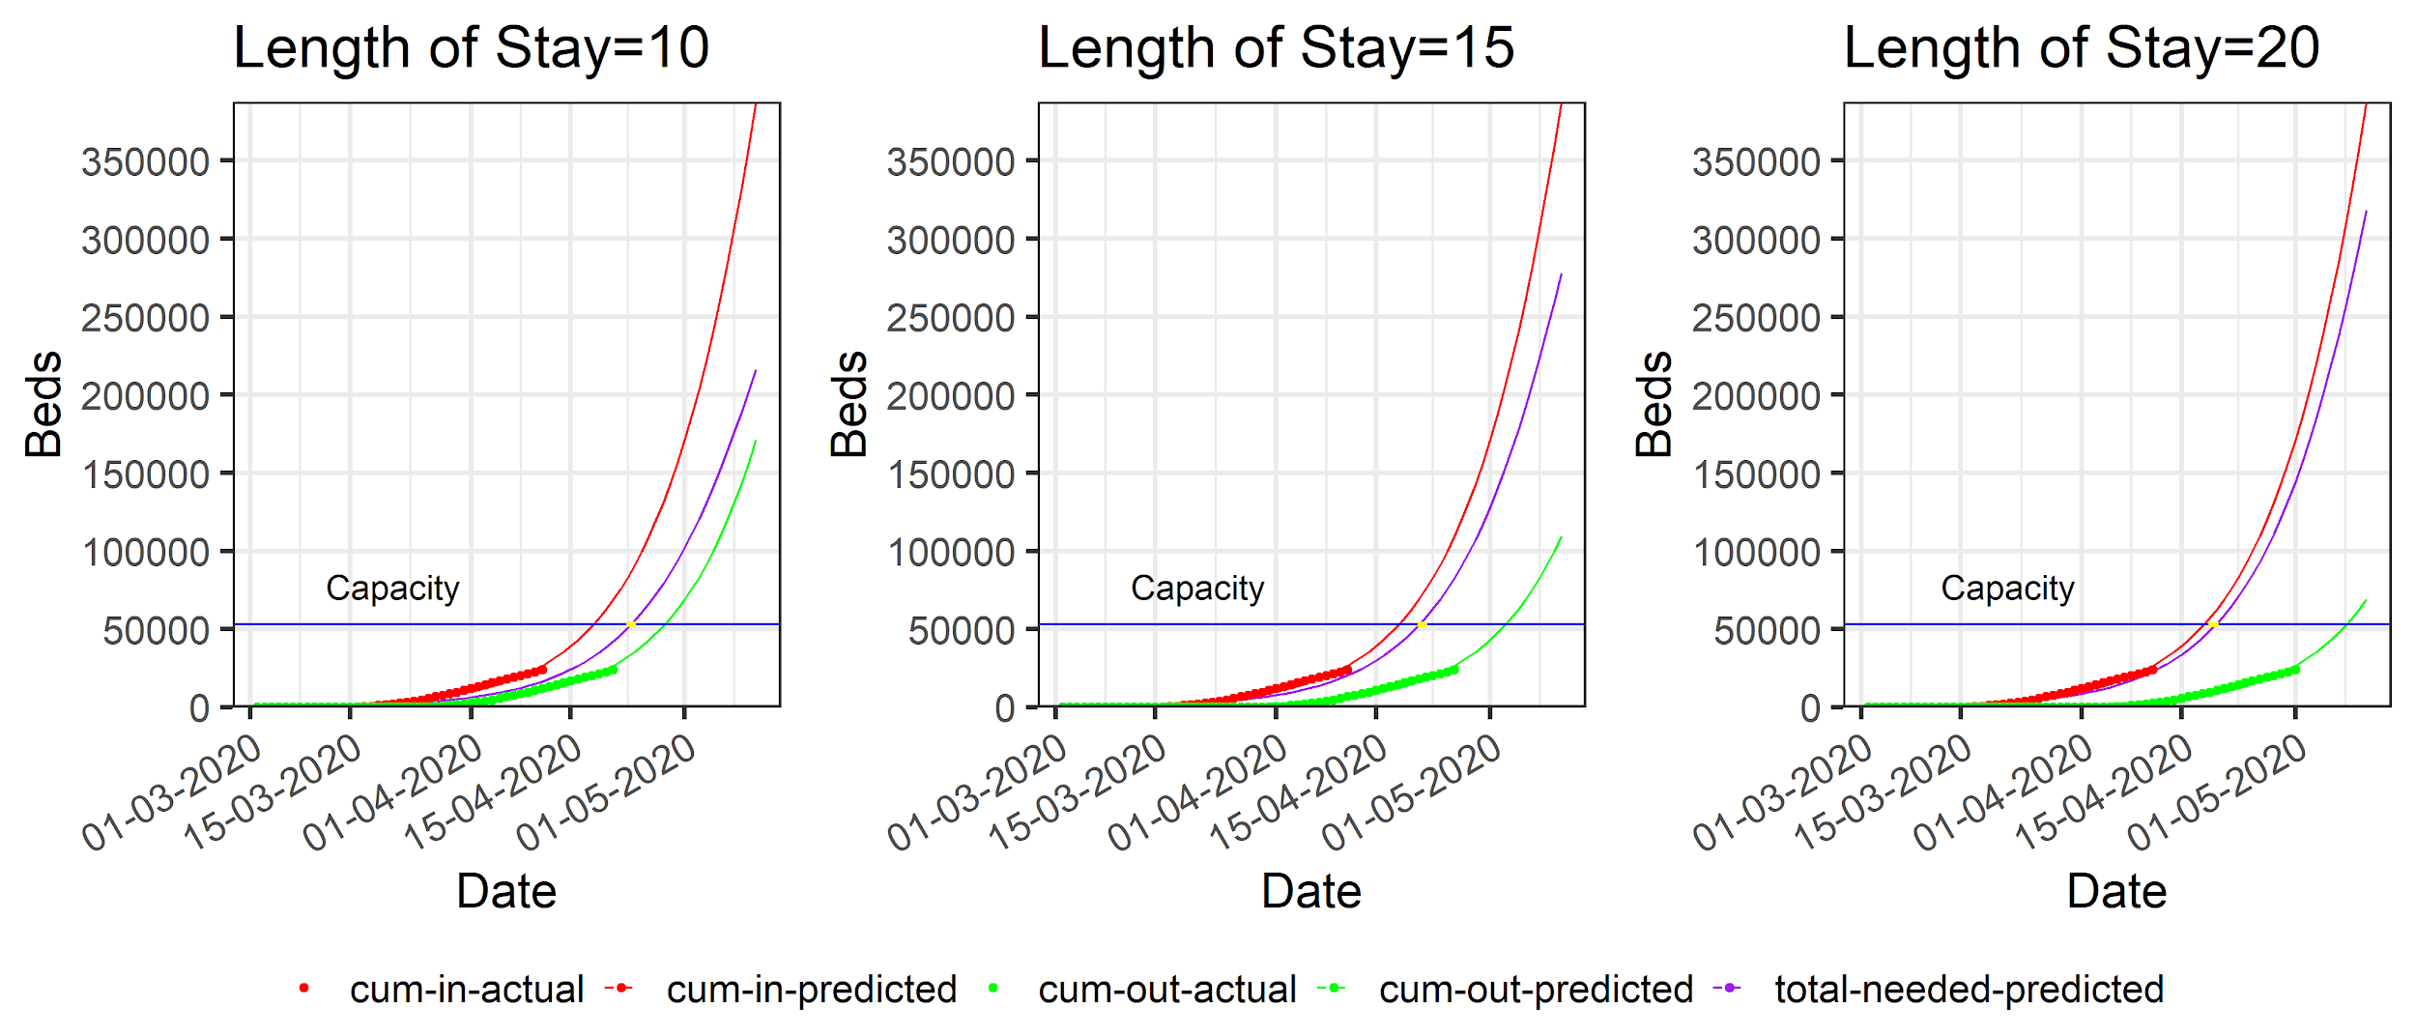

1. *Predict the daily new demand and release of Ventilators:* As per a World Health Organization report, and an article in the Lancet, about [17%](https://www.thelancet.com/journals/lancet/article/PIIS0140-6736(20)30566-3/fulltext) of hospitalizations for COVID-19 need a ventilator, and on an average a patient needs a ventilator after [7 days](https://www.who.int/docs/default-source/coronaviruse/who-china-joint-mission-on-covid-19-final-report.pdf) of hospitalization. Using these numbers, we can estimate the daily new demand for ventilators as 17% of new hospitalizations 7 days prior to that day. The daily release of Ventilators can be estimated as the daily new demand shifted by the average days of Ventilator use whose estimates range from 3 to 10 days. Total total number of patients hospitalized on any given day can be estimated as the cumulative predicted new demand - cumulative predicted release of ventilators until that day.

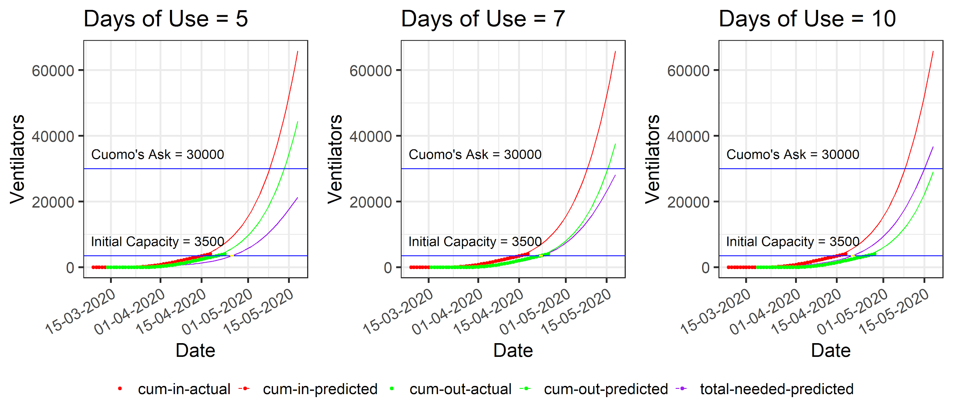

Repeating the above steps for NYC shows that if the exponential growth of active cases continues for the next one month, and the estimates mentioned above are not completely off the mark, then Cuomo’s Prophecy of the need for 30000 Ventilators may come true any second between the 15th May and 1st June, 2020.